**Project Design Phase-II**

**Technology Stack (Architecture & Stack)**

|  |  |
| --- | --- |
| Date | 03 October 2022 |
| Team ID | PNT2022TMID16504 |
| Project Name | Real-Time Communication System Powered by AI for Specially Abled |
| Maximum Marks | 4 Marks |

**Technical Architecture:**

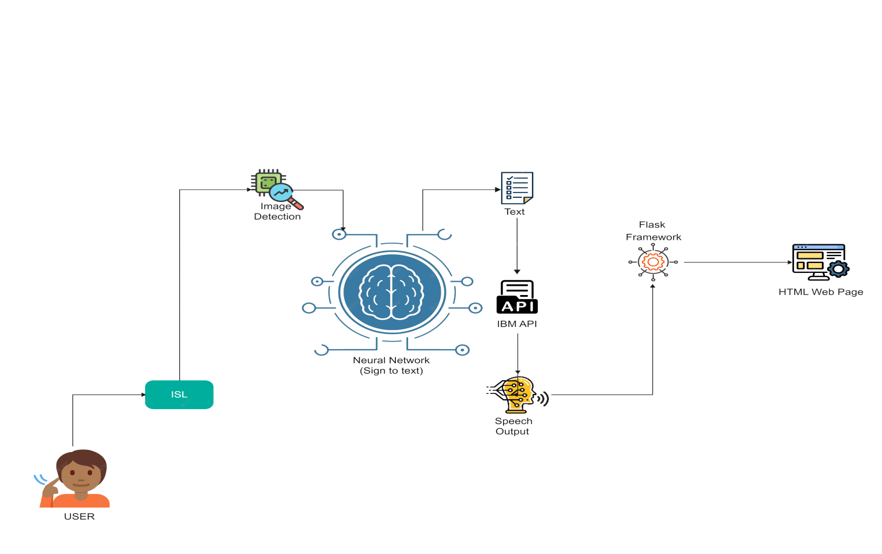

**Table-1 : Components & Technologies:**

|  |  |  |  |
| --- | --- | --- | --- |
| **S.No** | **Component** | **Description** | **Technology** |
|  | User Interface | User interacts with the neural network through  Home page | HTML, CSS, |
|  | Image Detection | The user data is captured by the camera in  which the signs are interpreted from the input using  Image detection. | Python,Keras, TensorFlow |
|  | Neural Network | The detected signs are then sent to the neural network where the signs are converted to text | CNN,Image classification(Keras) |
|  | File Storage | File storage requirements | IBM Cloud Storage |
|  | Text to Speech API | The text is then converted to speech through an API | IBM Watson API or Pyttsx3 (Python Module) |
|  | Machine Learning Model | Performs Image Classification and Recognition | CNN Model |
|  | Infrastructure (Server / Cloud) | Application Deployment on Local System / Cloud  Local Server Configuration:  Cloud Server Configuration : | IBM Cloud |

**Table-2: Application Characteristics:**

| **S.No** | **Characteristics** | **Description** | **Technology** |
| --- | --- | --- | --- |
|  | Open-Source Frameworks | The model is constructed using open-source frameworks.Techniques for picture categorization and gesture recognition are also employed with it. | Python Flask, OpenCV, Keras, Numpy,  Pandas,MatPlotLib. |
|  | Security Implementations | List all the security / access controls implemented, use of firewalls etc. | IBM Watson cloud  Security. |
|  | Scalable Architecture | When needed, IBM Cloud Bare Metal servers assist in achieving scalability. | IBM Cloud. |
|  | Availability | Global load balancing is used by IBM Cloud to guarantee the availability of a redundant, highly available platform to host the workloads and applications. | IBM Cloud |
|  | Performance | Utilizing the data centre and IBM Cloud APM,  workloads and cloud infrastructure are  with cognitive intelligence, handled.  Slowdowns and outages can be minimised and  continuously avoided in a hybrid  as Cloud APM supports the application world  moving on from performance evaluation  difficulty in identifying the source of the issue  occurrences and identifying problems before the  Affected is the application. | IBM Cloud APM |